Ridge is the one of the regularization techniques (also called L2) to avoid overfitting in linear regression model. Mean square error will be found for linear model, so this L2 adds regularization added to this mean square error, in mean square error we will find the difference between actual label and predicted label.
Following is the formula for MSE with L2 Penalty Alpha. That penalty is adding the sum of weight square to the loss function.
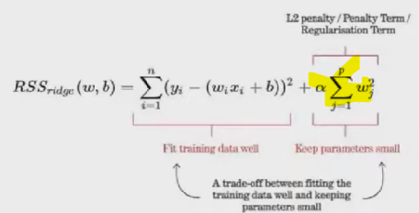
WITHOUT L2:
Model will learn very high weights, by adding L2 the model tries to shrinks the weight, if weight is too big L2 increase the penalty
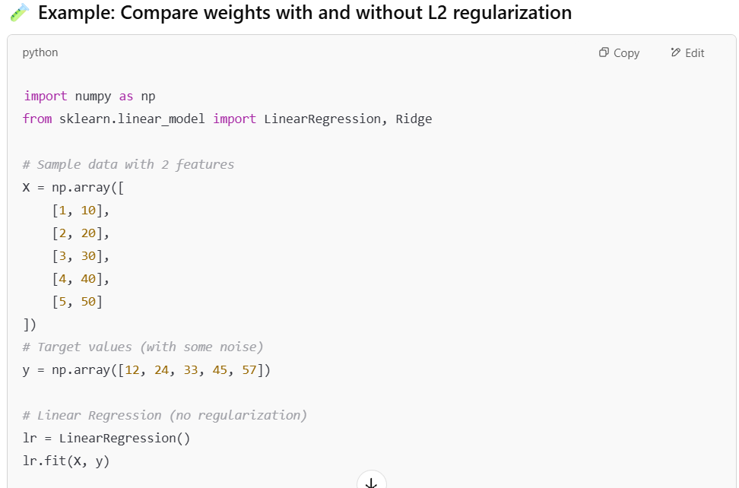
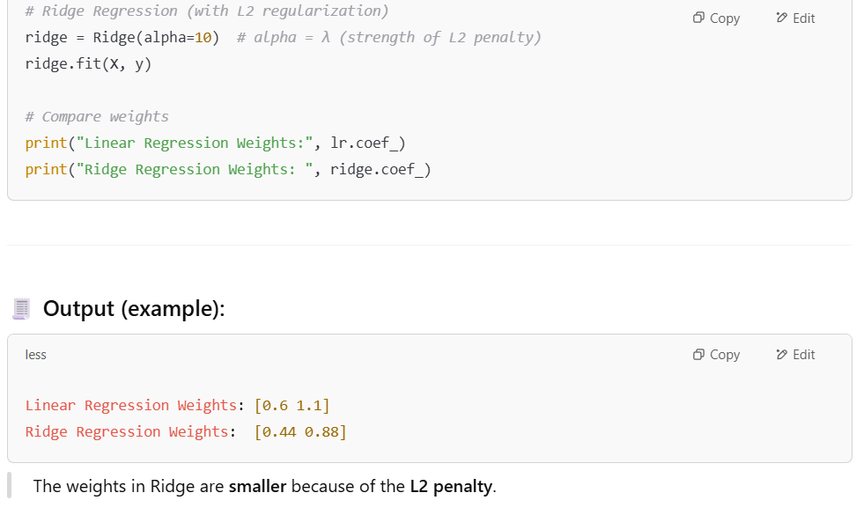


LASSO L1 REGULARIZATION
Here we add sum of absolute weights to the MSE, This regularization eliminates some feature by shrinks the high value model weights to zero. Will eliminates un important features.
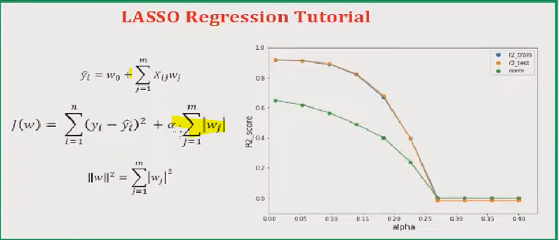
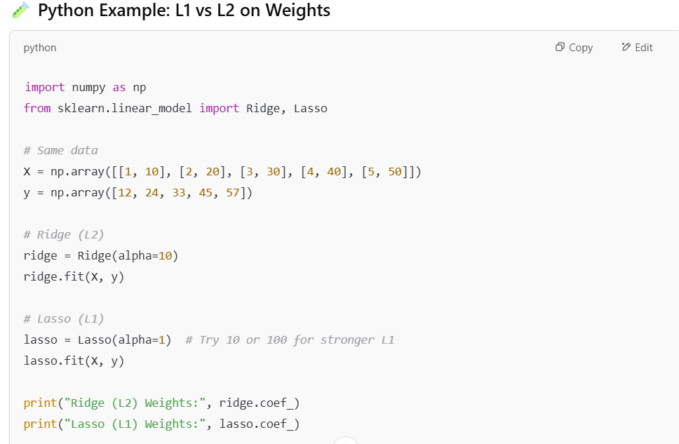
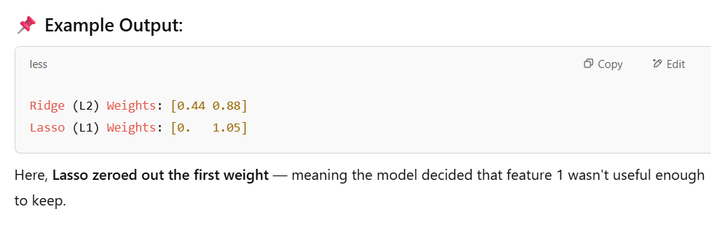
ELASTIC NET:
